Name ________________________________________ Period _______ Date _______
Aim: What is the relationship between the size of arcs and angles?

If two lines intersect inside a circle, the measure of the angle equals one-half the sum of the two arcs. (add)

Solve for x.
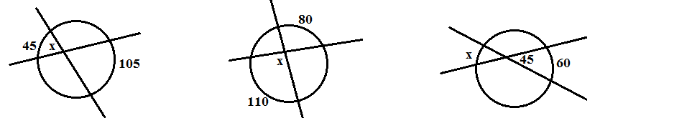

If two lines intersect outside of the circle, the measure of the angle equals one-half the difference of the two arcs. (subtract)

Solve for x.
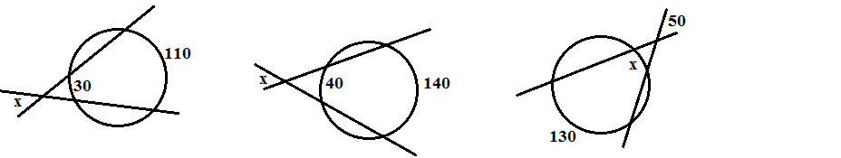

Solve for x.

